NEW BREXIT POLL: Remain leads — but the race is just too close to call

[Adam Payne](https://www.businessinsider.com/author/adam-payne)

Jun. 21, 2016, 9:31 AM

Two polls released on Tuesday show the Remain and Leave camps neck and neck in the EU referendum race with just 3 days to go until Britain votes on its EU membership.

Survation's latest phone poll has given Remain a slender lead of just one point — 45% to Leave's 44% — just hours after a SurveyMonkey poll indicated a [one-point lead for the Leave campaign.](http://uk.businessinsider.com/surveymonkey-eu-referendum-poll-shows-lead-for-leave-2016-6)

After weeks of volatility across EU referendum surveys, public opinion appears to have stabilised with very little to choose between the rival campaigns going into June 23.

Business Insider has annotated its live opinion polls chart to illustrate this.

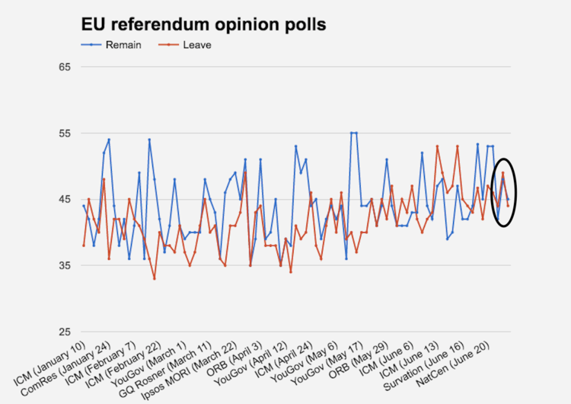Business Insider / What Uk Thinks dataThe close nature of the contest ought to have figures on both sides of the debate very nervous ahead of Thursday's vote.

A new ComRes survey is expected to be released today and a handful more will be published on the day of the referendum. Unlike in general elections, there will be no exit polls for the EU referendum meaning opinion polls remain our only insight to how the public intends to vote.